# Recurrent heatwaves slow down the recovery of phytoplankton community

Francesco Polazzo1, Markus Hermann2, Melina Crettaz-Minaglia3, Andreu Rico4

1 Department of Evolutionary Biology and Environmental Studies, University of Zurich, Zurich, Switzerland

2 Department of Aquatic Ecology, Eawag, Swiss Federal Institute of Aquatic Science and Technology, Dübendorf, Switzerland

3 IMDEA Water Institute, Science and Technology Campus of the University of Alcalá, Avenida Punto Com 2, 28805 Alcalá de Henares, Madrid, Spain

4 Cavanilles Institute of Biodiversity and Evolutionary Biology, University of Valencia, c/ Catedrático José Beltrán 2, 46980, Paterna, Valencia, Spain

**Email**: [francesco.polazzo@uzh.ch](mailto:francesco.polazzo@uzh.ch) (FP); markus.hermann@eawag.ch (MH); crettaz.melina@uader.edu.ar (MCM); [andreu.rico@uv.es](mailto:andreu.rico@uv.es) (AR)

**Corresponding author**: Andreu Rico [andreu.rico@uv.es](mailto:andreu.rico@uv.es)

**Keywords**: resilience, ecological stability; heatwaves; critical slow down, community rescue

**ORCID**: FP: 0000-0003-2092-501; MH: 0000-0003-2166-5418; MCM: 0000-0003-4714-803X; AR: 0000-0002-1820-4218

# Abstract

Heatwaves (HWs) are predicted to increase in frequency and severity. This is concerning as HWs can detrimentally impact the ecological resilience of communities, pushing them over ecological thresholds. Yet, there is limited information about how ecological resilience of communities is going to be impacted by recurrent HWs. Here, we used data from an outdoor freshwater mesocosm experiment where we exposed a semi-natural phytoplankton community to three subsequent HWs. We hypothesised that two main mechanisms may affect community resilience when exposed to recurrent perturbations: critical slowing down or community rescue. Slowing down would determine a reduction in resilience an eventually community collapse, whereas rescue would increase community resilience and maintain stable community and ecosystem functioning. We found evidence for critical slowing down, but not for community rescue. Community productivity and dissolved oxygen both gradually decreased in recovery after each HW, and sharply declined after the third HW. The decline in functional end points was linked to a significant compositional turnover in the phytoplankton community. Although we did not find evidence for tipping points, we highlight the importance of monitoring critical slowing of recovery in communities experiencing repeated extreme perturbations.

# Introduction

Climate change is an urgent global challenge characterized by significant alterations in weather patterns (IPCC 2023). One of the most concerning aspects of climate change is the increasing frequency and intensity of extreme events, such as hurricanes, floods, droughts, and heatwaves (Fischer *et al.* 2021). Particularly, heatwaves (HWs) have been projected to increase in frequency and severity globally (Perkins *et al.* 2012), affecting the freshwater realm (Woolway *et al.* 2021, 2022). Several studies show that HWs can detrimentally impact the diversity and functioning of freshwater ecosystems (Correa-Araneda *et al.* 2020; Mouthon & Daufresne 2006; Polazzo *et al.* 2022; Woodward *et al.* 2016). Yet, the effects of HWs on ecological stability have been hardly assessed (Polazzo *et al.* 2022). The few studies that investigated the effects of HWs on ecological stability have shown that HWs can negatively affect several dimensions of functional and compositional stability of freshwater populations and communities, including resistance, recovery and temporal stability (Polazzo *et al.* 2023; Ross *et al.* 2021).

Additionally, HWs have been reported to decrease the resilience of aquatic ecosystems, causing critical transitions to alternative stable states (Bertani *et al.* 2016; Meunier *et al.* 2024; Turner *et al.* 2020; Wernberg *et al.* 2016). In this context, resilience is defined as the ability of a system to absorb perturbations without transitioning to an alternative equilibrium or stable state (Holling 1973). Abrupt shifts, critical transition or tipping points, are all concepts related to the threshold-like behaviour of some systems in which multiple stable states are possible, and describe the transition from one state to another one determined by some environmental change that promote a positive feedback loop that maintains the systems in the alternative stable state (Scheffer *et al.* 2001; Scheffer & Carpenter 2003).

At present, evidence for HW – driven abrupt shifts or collapses is limited in freshwater systems (Bertani *et al.* 2016; Filiz *et al.* 2020; Polazzo *et al.* 2022). Scarce support for HW related collapse may be linked to the fact that most empirical studies analyse the impact of a single HW event (Polazzo *et al.* 2022), and the few available studies considering recurrent HWs have not focused on assessing cumulative effects on ecological resilience (Hermann *et al.* 2023, 2024). Yet, with heatwaves expected to become more common in the future, concerns have raised about whether and how natural communities can sustain multiple recurring HWs.

How repeated perturbations affect the resilience of a system can be understood through two major ecological frameworks: critical slowing down and community rescue. Critical slowing down is the process by which functional and / or structural recovery of communities decreases when they are close to a tipping point due to gradually increasing pressure or when exposed to repeated perturbations (Veraart *et al.* 2012). The exact shifting point is notoriously difficult to predict, as ecosystems exhibit complex, nonlinear interactions among various biotic and abiotic components, where small changes can lead to disproportionate effects (van Nes & Scheffer 2007). Therefore, the focus has shifted to deducing processes from patterns. This involves identifying observable signals in measurable endpoints of a biological system that indicate changes in the system’s behaviour, which may result in a critical transition. In the last two decades, the phenomenon known as critical slowing down has been indicated as a possible early warning signal (EWS) of an approaching abrupt shift, derived from dynamic systems theory (Rietkerk *et al.* 1996; Strogatz 2019). The theory suggests that EWSs could be based on the idea that recovery rates from disturbances tend to zero as a system approaches a transition point (Rietkerk *et al.* 1996; Strogatz 2019; Veraart *et al.* 2012).

On the other hand, community rescue theory suggests that ecological or evolutionary processes may restore recovery under stressful conditions that would have been detrimental to the community in its original form, thereby preventing community or ecosystem collapse (Bell & Gonzalez 2011; Carlson *et al.* 2014; Samani & Bell 2010). Although empirical examples of community rescue are scarce (Fugère *et al.* 2020), it is considered a key mechanism that enhances stress resistance in communities and helps maintaining aggregate community properties, such as biomass, under stressful conditions. Both frameworks are plausible and have been documented in communities undergoing repeated perturbations (Fugère *et al.* 2020; Veraart *et al.* 2012). However, to the best of our knowledge, they have not been applied to assess the impacts of recurrent heatwaves in freshwater ecosystems. Hence, the extent to which critical slowing down or community rescue occur in aquatic communities exposed to recurrent HWs is yet unknown.

The aim of this study was to assess the role of critical slowing down or community rescue in explaining the functional response of a phytoplankton community exposed to recurrent HWs. For this, we used data coming from an outdoor pond mesocosm experiment conducted in Spain where a semi-natural phytoplankton community was exposed to three subsequent heatwaves separated one another by one week at ambient temperature, and the change in the short-term recovery after each HW was assessed. If community rescue prevails, the first HW will determine a decline in community functioning, which may be recovered through a compositional change that promotes stress-tolerant species (Fugère *et al.* 2020). This new community composition might be more resistant to a following HW, and thus determine higher community stability to future HWs. Contrary, if critical slowing down prevails, the stress accumulation due to recurrent HWs, the recovery rate of the community will gradually decline after each HW, reducing community resilience and driving the community to a collapse. Here we tested these two theories and assessed which of them is more likely to occur in a phytoplankton community experiencing recurrent HWs.

# Materials and Methods

## Experimental design

An outdoor mesocosm experiment was performed at the facilities of the IMDEA Water Institute (Alcalá de Henares, Madrid, Spain) between April and July 2021. The 8 mesocosms used in this study were filled with 40 cm of sediments and 850 L of water from an artificial lagoon. The biological community of the mesocosms was composed of phytoplankton, zooplankton, and macroinvertebrates, and was allowed to establish and homogenize among experimental units for 2 months prior to the start of the experiment. Detailed information on the experiment can be found in (Hermann *et al.* 2024).

Four mesocosms were used to simulate the HW scenario (n = 4), which was formed by three repeated HWs (Figure 1); while the remaining four mesocosms were kept at ambient temperature for the whole experimental duration and were used as temperature controls (n = 4). The HWs treatment consisted of three HWs lasting 7 days each and separated one another by 7 days of ambient temperature. In the HWs treatment, the temperature was +8 °C above the control temperature, meaning that the absolute temperature of the HWs increased progressively from the first to the third HW as the water temperature in the control mesocosm warmed because of seasonality.

All temperature manipulations and recordings were carried out using a transportable temperature and heatwave control device (TENTACLE) applicable for aquatic micro-and mesocosm experiments (Hermann *et al.* 2022). Additionally, we place a Hobo logger (Onset Computer Corporation, Bourne, MA, USA) in one control mesocosm and in one mesocosm undergoing the HWs treatment to have an independent water temperature measurement.

## Phytoplankton sampling and biomass quantification

The phytoplankton community was sampled on days -4, 3, 10, 15, 24, 30, and 38 relative to the start of the first HW. Samplings were performed by taking depth-integrated water samples with a polyvinyl chloride (PVC) tube (six sub-samples per mesocosm mixed in a bucket). Next, 250 mL of this water sample were introduced into glass amber bottles and 10% Lugol’s iodine was added for preservation. Phytoplankton taxa identification and counts were performed on a 1 mL subsample by means of an inverted microscope and a Sedgewick-Rafter counting cell (Graticules Optics).

Every phytoplankton taxon was digitally photographed with scale reference using a camera Samsung 12 mp (4032 X 3024, JPG format), and measured using the Image J software (Schneider *et al.* 2012). The biovolume (μm3/org) of the phytoplankton individuals was calculated using geometric models according to Hillebrand *et al.* (1999) and Sun & Liu (2003). Biovolume was transformed to fresh weight using the following ratio 1 μg = 106 μm3, assuming specific density of water = 1 kg/L.

## Ecosystem functioning

We measured chlorophyll – *a* (chl *a*; μg/L) as proxy for primary productivity, as it represents the living part of the phytoplankton biomass. Chl *a* concentration was measured on days -4, 3, 7, 10, 15, 24, 30 and 38. We also measured dissolved oxygen (DO; mg/L) during the experimental period. Oxygen is essential to all aerobic organisms, and its dynamics in freshwater involve interconnected physical and biological processes that form the basis of the functioning of freshwater ecosystems. DO was measured on days -4, 3, 7, 10, 15, 24, 30, and 38. Chl *a* and DO were measured *in situ* by using a portable multi-meter (YSI Pro DSS 626,973–01).

## Statistical analysis

To investigate the effect of the HWs on DO and chl *a* in the mesocosms, we employed a linear mixed-effects model (LMM) using the lmer function from the “lme4” package (Bates *et al.* 2015). The model included HW, time, and their interaction as fixed effects, with mesocosm identifier as a random effect to account for the repeated measures within each mesocosm. The model diagnostics were performed using the “check_model” function from the performance package (Lüdecke *et al.* 2020) to ensure the assumptions of the LMM were met. We log- transformed the raw data of DO and chlorophyll-a concentration to meet the model’s assumptions. When an interaction effect between HW and time was found we performed a post-hoc comparison across different days using the “emmeans” package (Lenth *et al.* 2024) to perform estimated marginal means (EMMs) analysis.

To quantify whether there was a slowing down in recovery after each HW, we first calculated the difference in DO or chlorophyll-a concentration between the controls and the mesocosms exposed to HWs. Then, we used the value of the slope of the linear regression between two subsequent time points (during and after a HW) as a measurement of recovery. For that, we calculated the slope between day 3 and 10 (first HW), 15 and 24 (second HW), and 30 and 38 (third HW). A positive slope was interpreted as a sign of recovery, whereas a negative slope as increasing magnitude of effects and absence of recovery. In case of critical slowing down, we would expect the slope of the recovery to become increasingly less positive when comparing the three HW events, and perhaps eventually negative. In case of community rescue, we expect the slope to become close to zero after each HW, which would suggest an improved resistance to previously experienced stress.

Both critical slowing down and community rescue are mechanistically underpinned by compositional changes that can reduce resilience in the case of critical slowing down or improve it in the case of rescue. To quantify changes in phytoplankton community composition, we performed a non-parametric permutational multivariate analysis of variance (PERMANOVA), function adonis2 of the R package “vegan” (Oksanen *et al.* 2019) with 999 permutations and based on Bray-Curtis distances calculated on the biomass of phytoplankton taxa.

To further assess the dissimilarity in community composition among control and HW treatments, the Similarity Percentage (SIMPER) analysis was conducted using the function “simper” of the package “vegan” (Oksanen *et al.* 2019). This method identifies the contributions of individual taxa to the dissimilarity between groups to the overall Bray-Curtis dissimilarity.

All statistical analysis and figures have been done in R (R version 4.2.2; R Core Team 2022). Data and code to reproduce the analysis and figures is available at <https://github.com/FrancescoPola/rescue_critical_slowing>.

# Results

## Temperature manipulations

Throughout the whole experiment the average ambient water temperature was 20°C and ranged between 13 °C and 30 °C (Fig. 1). Except for a few temporary declining temperature periods, the ambient water temperature gradually increased during the experiment. The average HW water temperature was 24°C, and ranged between 13°C and 36 °C.

Figure 1. Water temperature dynamics over time in ambient mesocosms (blue line) and HWs mesocosms (orange line). The drop in temperature in the HW treatment during the first HW was caused by a technical failure of the TENTACLE machinery during few hours.

## Dissolved oxygen

DO declined sharply during the first HW but recovered quickly to values higher than the control between the first and the second HW (Fig. 2a). The second HW determined a similar decrease in DO, but with full recovery and a less steep recovery trajectory. However, the third HW drastically decreased DO as it progressed. Following the last HW (day 38), DO further declined, showing no signs of recovery (Fig. 2a). The trend was also confirmed by the calculated slopes of the recovery, which became less positive after the second HWs (slope between days 3 – 10: 0.332; slope between days 15 – 24: 0.076), and eventually turned negative after the third HW (slope between days 30 – 38: - 0.053; Fig. 2b).

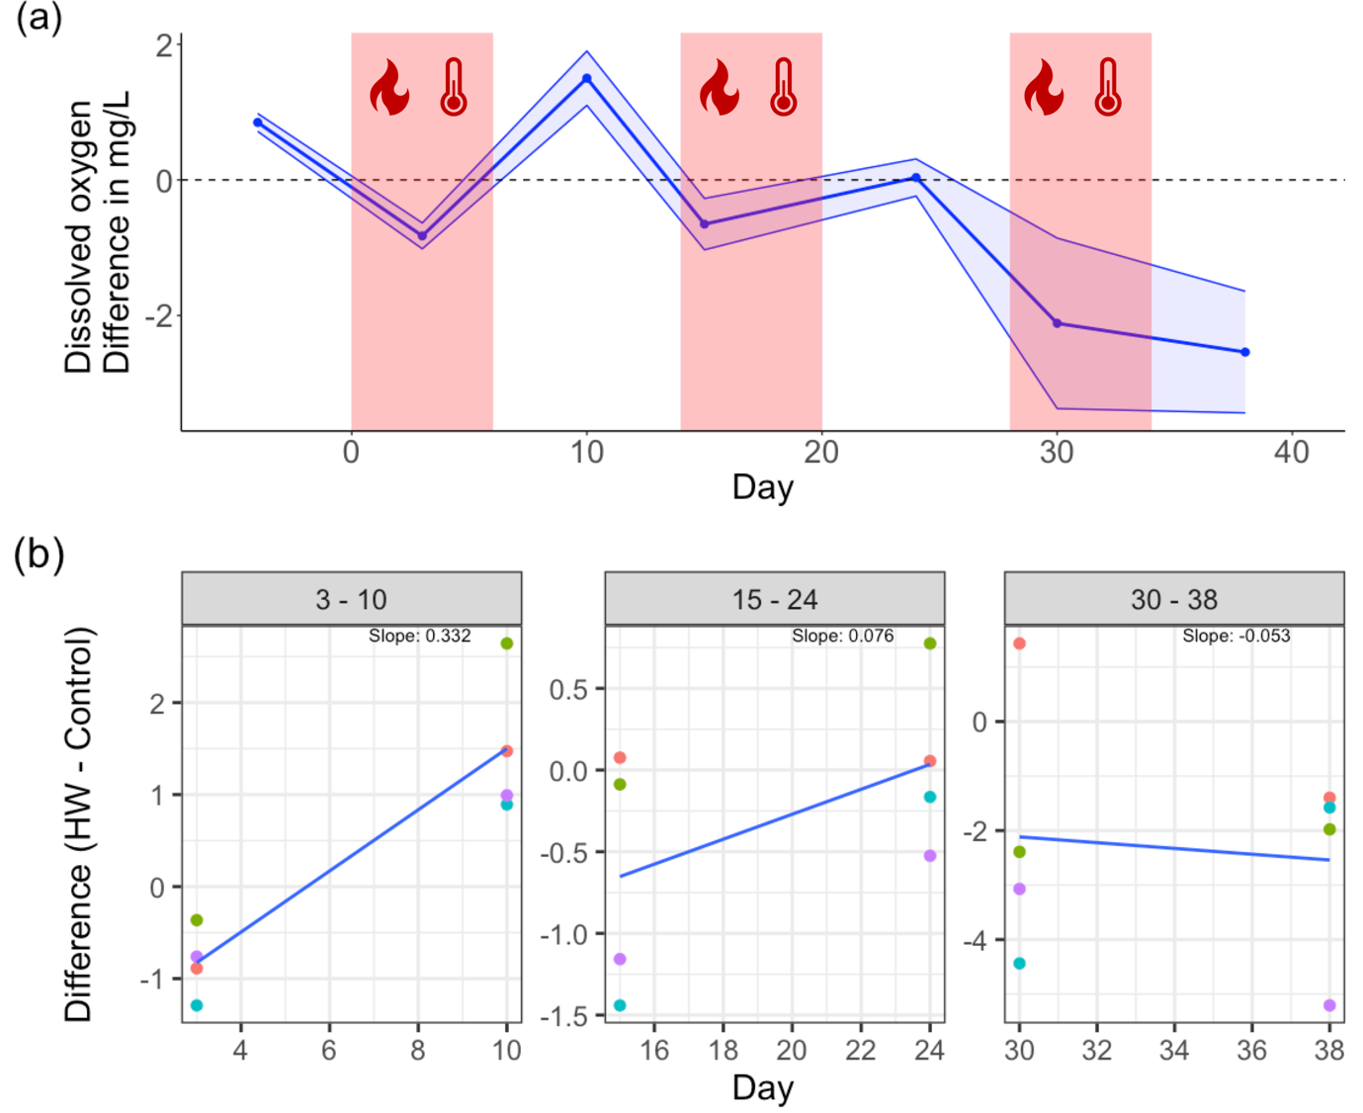

Figure 2. Dissolved oxygen dynamics over time. (a) shows the difference in DO between mesocosm undergoing the HWs treatment and the control mesocosms (dashed line at zero). The red areas show the timing of the three heatwaves. (b) shows the slopes of the linear regression connecting two subsequent time point (during and after a HW) of the difference between DO in control and HW mesocosms. In (b), the first panel shows the slope between day 3 and 10, the second panel shows the slope between day 15 and 24, and the third panel shows the slope between day 30 and 38, which correspond to the first, second and third HWs, respectively.

The LMM showed a significant interaction between HW and time of (estimate: -0.007, 95% confidence interval of -0.012 to -0.002; p-value: 0.010) suggesting a time-dependent effect of the HWs on the DO concentration, that became more negative with time (Appendix, Table 1).

The post-hoc analysis showed that there was a significant difference (p < 0.05) in the DO concentration between the control mesocosms and the mesocosms undergoing HWs from day 24 onwards. After day 24, the DO concentration was always significantly lower in the mesocosms exposed to the HWs (Appendix Table 2).

Chl *a* showed a slight decline after the first two HWs. Though, after the third HW, the chl *a* concentration sharply declined in the mesocosms experiencing the HWs compared to control levels (Fig. 3). This trend was highlighted also by the calculated recovery slopes. After the first and second HWs, the slope was slightly negative (slope between days 3 – 10: -0.058; slope between days 15 – 24: -0.08). Yet, after the third HW, the slope became more negative, decreasing its value by roughly one order of magnitude (slope between days 30 – 38: -0.514).

The LMM analysis showed that the HW treatment had a significant effect on the chlorophyll- a concentration (estimate: -0.65, 95% confidence interval of -1.22 to -0.078; p-value: 0.041; Appendix, Table 3).

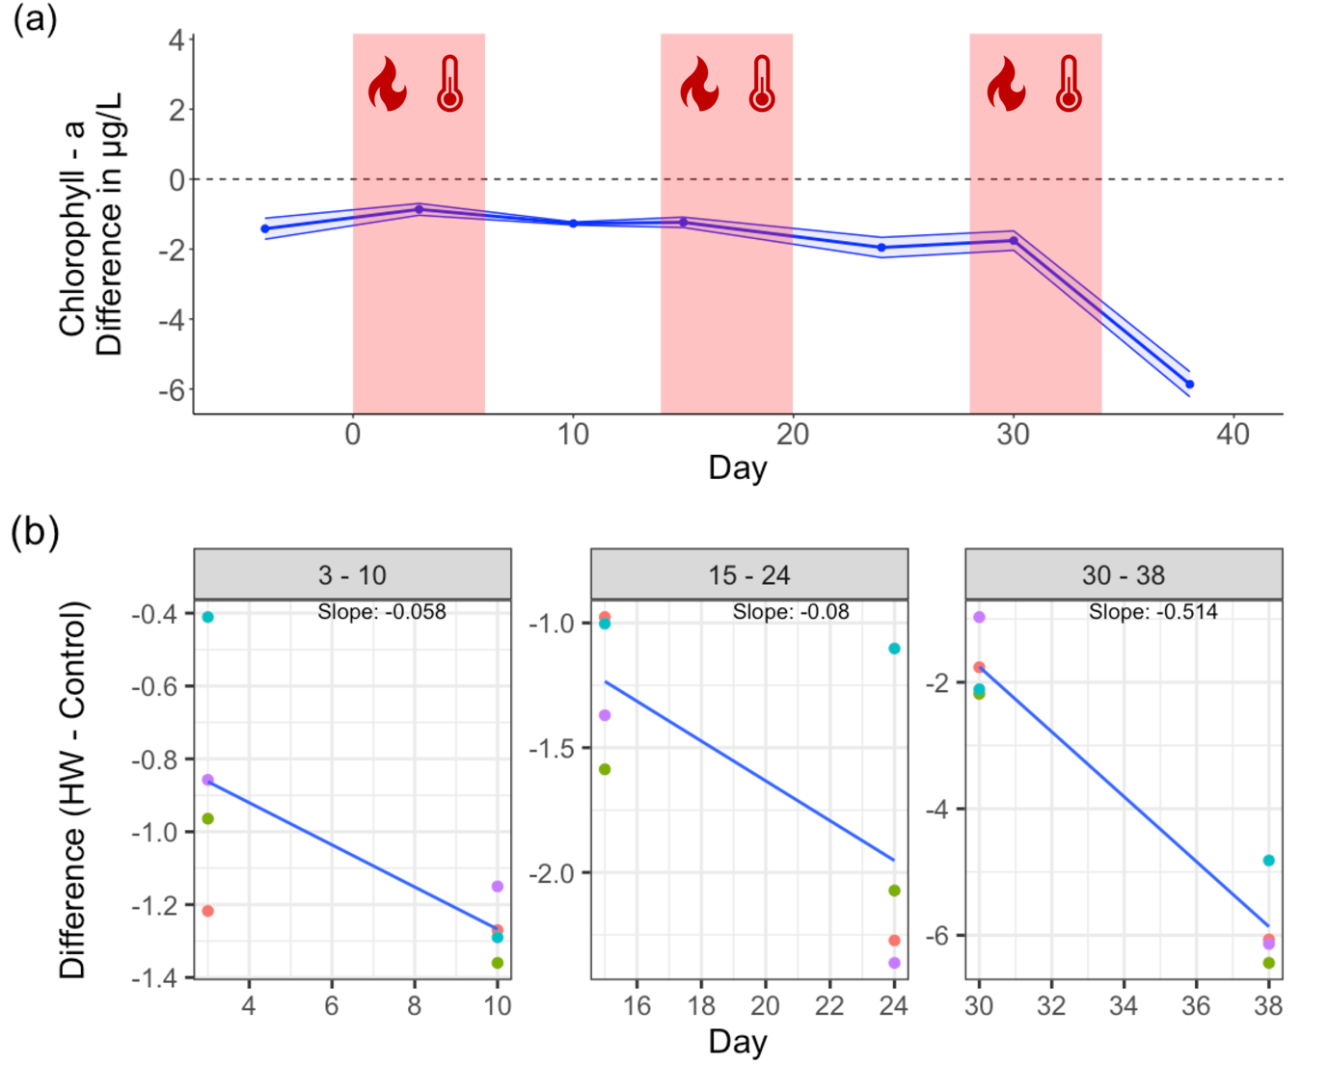

Figure 3. Chlorophyll *- a* concentration dynamic over time. (a) shows the difference in Chlorophyll *- a* between mesocosms undergoing the HWs treatment and the control mesocosms (dashed line at zero). The red areas show the three heatwaves. (b) shows the slopes of the linear regression connecting two subsequent time points (during and after the HW) of the difference between Chlorophyll *- a* in control and HW mesocosms. In (b), the first panel shows the slope between day 3 and 10, the second panel shows the slope between day 15 and 24, and the third panel shows the slope between day 30 and 38, which correspond to the first, second and third HWs, respectively.

## Phytoplankton community composition

The relative biomass of the different phytoplankton groups in the mesocosms undergoing the HW treatment showed a gradual turnover over the course of the experiment and gradually became more and more dissimilar to the control mesocosms (Fig. 4). The increased compositional dissimilarity was confirmed by the PERMANOVA analysis, which highlighted a significantly different community composition between the control and the mesocosms exposed to the HWs on day 10 (F = 4.21, p = 0.027), 30 (F = 3.10, p = 0.032), and 38 (F = 2.55, p = 0.026; Appendix, Table 4). Significant differences on day 10 were related to a significant decline in Charophyta, Cryptophyta, and Bacillariophyta biomass in the HW treatment compared to the control (SIMPER, Table 7 of the Appendix). On day 30, the compositional change was driven by a significant decline in Cryptophyta (SIMPER, Table 10 of the Appendix), whereas on day 38 there was a significant reduction in Cryptophyta and Chlorophyta biomass in HW mesocosms (SIMPER, Table 11 of the Appendix).

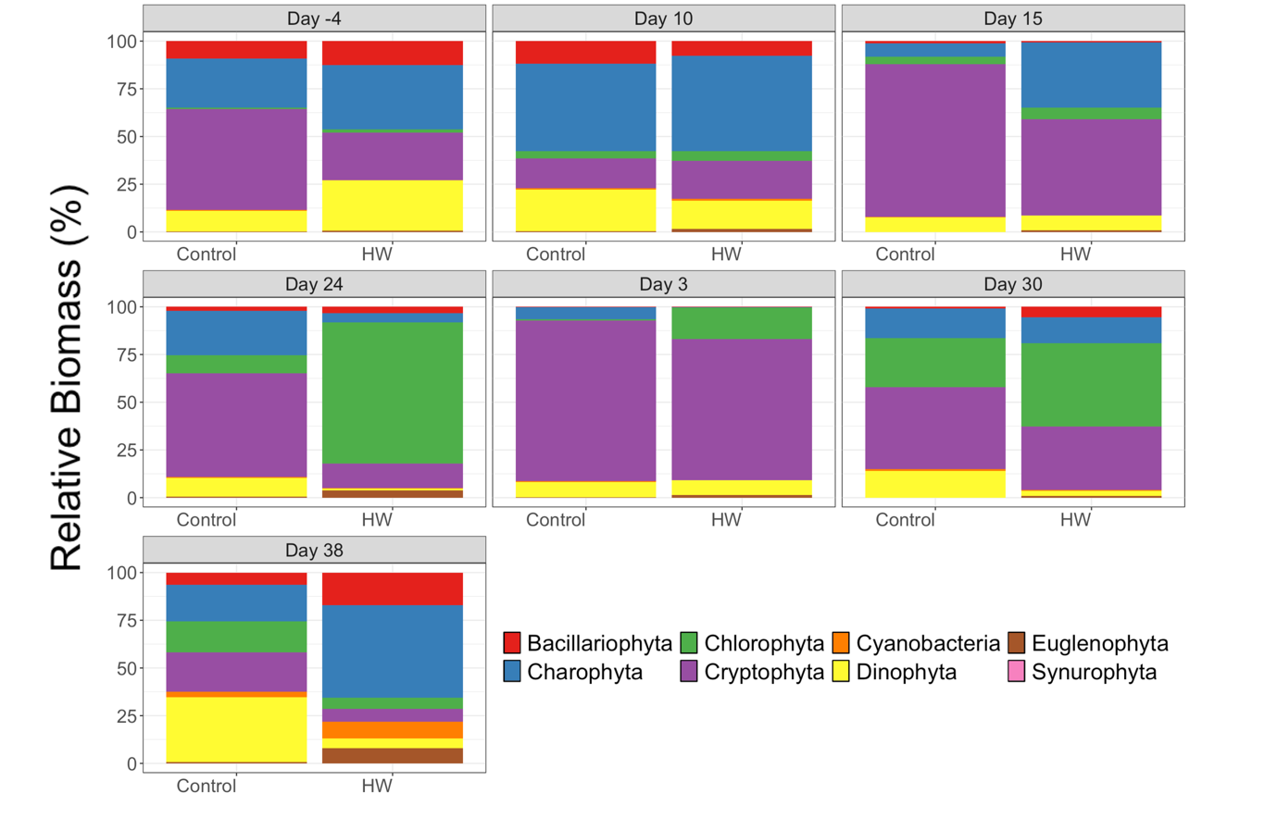

Figure 4. Mean relative biomass of different phytoplankton taxa in the control and the mesocosms exposed to HWs in different time points of the experiment.

# Discussion

Our experiment highlights the profound impact of recurring HWs on the resilience of freshwater ecosystems. Our findings align with the growing body of literature that highlights the detrimental effects of HWs on aquatic ecosystems (Hermann *et al.* 2023, 2024; Polazzo *et al.* 2022; Ross *et al.* 2021). Critically, we show that a series of three, repeated HWs can slow down the rate of recovery of phytoplankton communities in freshwater ecosystems and the functions they perform. The observed trends in dissolved oxygen (DO) levels suggest a pattern of critical slowing down, indicated by the gradual reduction in recovery rate with repeated disturbances that determined a gradual erosion of resilience (Veraart *et al.* 2012). Initially, the system exhibited resilience, as evidenced by the quick recovery of DO levels after the first HW. However, the recovery rate decreased progressively after subsequent HWs, and by the third HW, the system failed to recover, indicating a potential loss of resilience and perhaps the approach of a tipping point. The significant interaction between HW and time from the linear mixed model (LMM) analysis further supports the notion of a time-dependent deterioration in ecosystem functioning due to recurrent HWs.

Chlorophyll-*a* concentrations mirrored the DO patterns with slight declines after the first two HWs and a drastic drop after the third. This suggests that the primary productivity of the phytoplankton community was increasingly compromised with each successive HW. The steeper negative slope in chl *a* recovery after the third HW indicates a critical point where the community's ability to maintain its primary productivity was severely hindered. The significant effect of HWs on chl *a* concentration from the LMM analysis corroborates the observed trend and emphasizes the cumulative stress imposed by recurrent HWs.

The gradual loss of resilience found in our experiment was linked to an increased compositional dissimilarity in the phytoplankton community. Indeed, the turnover in phytoplankton community composition towards increasing dissimilarity with the control mesocosms throughout the experiment indicates a shift towards a new community state. The significant compositional differences detected by the PERMANOVA analysis on days 10, 30, and 38 highlight the extent of this shift. Particularly towards the end of the experiment, the compositional dissimilarity was driven by a significant reduction in the biomass of Cryptophyta, Dinophyta, and Chlorophyta in the HW treatment. The new community composition did not promote stress-tolerant species able to maintain ecosystem functioning and increase resilience, as testified by the sharp decline in chl *a* concentration. Although community rescue is usually linked to a strong compositional change, this compositional change should determine an increased resistance to stress and consequent ability to maintain functional levels (Fugère *et al.* 2020). Since we found the opposite (i.e. compositional change determined a decline in resistance to following HW and decline in functioning), we exclude that any rescue process happened in our experiment.

On the contrary, the increased compositional dissimilarity linked to the increasingly impaired recovery rate further supports the critical slowing down process. Indeed, critical transitions to alternative stable state are often related to dramatic shifts in composition (Bertani *et al.* 2016; Meunier *et al.* 2024; Wernberg *et al.* 2016). The classic example is the shift from clear water state dominated by macrophyte to a turbid water state dominated by phytoplankton in shallow lakes (Scheffer 2009). The compositional shift is a common feature of critical transition across ecosystems and has been reported in marine (Meunier *et al.* 2024) and terrestrial systems (Eby *et al.* 2017). Hence, our study aligns with the body of literature describing a strong compositional shift which relates to dramatic changes in ecosystems functioning that may result in critical transitions (Eby *et al.* 2017; Meunier *et al.* 2024)

A recent meta-analysis has demonstrated that critical transitions are not commonly observed in empirical data (Hillebrand et al., 2020). Nevertheless, it is not necessary for a community to tip in order to show a slowing down in recovery. van Nes & Scheffer (2007) suggested that critical slowing down may not only be related to a critical transition or tipping point but could also generically indicate an increased sensitivity of the system to repeated perturbations. Critical slowing down may thus provide important information in cases where the threshold leading to a critical transition has not yet been reached, and thus working as an early warning signal (EWS), but may be informative even in systems that do not have multiple stable states at all.

Indeed, we did not find any evidence for a critical transition happening in our experimental systems. Although critical slowing down may appear even far away from the tipping point (Drake & Griffen 2010; van Nes & Scheffer 2007), we have no evidence that a tipping point was approaching in our study,. Nevertheless, critical slowing down is a highly relevant phenomenon for stability in general, regardless of whether a transition occurs. Understanding whether and why a system undergoing repeated perturbations loses resilience and recovery potential has deep ecological and management consequences, even in systems that do not exist in multiple stable states. Indeed, monitoring critical slowing down can serve as an early warning signal of a system losing its ability to sustain additional perturbations. This early detection allows for proactive management strategies to be implemented. By identifying when a system is becoming less resilient, managers can adjust resource allocation, conservation efforts, and restoration activities to enhance ecosystem stability and functionality. For instance, wetlands provide essential ecosystem services, such as water filtration, flood control, and habitat for many species (Mitsch *et al.* 2015). Wetlands are threatened by urban development, pollution, and water extraction (Martínez-Megías & Rico 2022; Mitsch *et al.* 2015). Wetlands’ loss of resilience can be highlighted by decreased water levels and flow rates due to excessive water extraction, by increased levels of pollutants and sediments in the water, and by loss of wetland vegetation and decline in wildlife populations (Martínez-Megías & Rico 2022). When such EWSs appear, managers can implement strategies to restore ecosystem resilience by e.g. investing in water management infrastructure to ensure sustainable water levels and flow rates, implementing stricter regulations on pollutants entering the wetland and create buffer zones to reduce sediment runoff, and replanting native vegetation to stabilize soil and improve habitat quality for wildlife (Ye *et al.* 2022).

In our study, the repeated stress caused by increasingly stronger HWs led to a drastic change in the composition of the phytoplankton community. The new compositional configuration was unable to maintain and / or recover functional levels like unperturbed systems, suggesting an overall increase in vulnerability to subsequent perturbations. These results force us to evaluate the consequences of climate change-induced extreme weather events on the functioning of communities and ecosystems in the future.

# References

Bates, D., Mächler, M., Bolker, B.M. & Walker, S.C. (2015). Fitting linear mixed-effects models using lme4. *Journal of Statistical Software*, 67.

Bell, G. & Gonzalez, A. (2011). Adaptation and Evolutionary Rescue in Metapopulations Experiencing Environmental Deterioration. *Science*, 332, 1327–1330.

Bertani, I., Primicerio, R. & Rossetti, G. (2016). Extreme Climatic Event Triggers a Lake Regime Shift that Propagates Across Multiple Trophic Levels. *Ecosystems*, 19.

Carlson, S.M., Cunningham, C.J. & Westley, P.A.H. (2014). Evolutionary rescue in a changing world. *Trends in Ecology & Evolution*, 29, 521–530.

Correa-Araneda, F., Tonin, A.M., Pérez, J., Álvarez, K., López-Rojo, N., Díaz, A., *et al.* (2020). Extreme climate events can slow down litter breakdown in streams. *Aquatic Sciences*, 82, 1–7.

Drake, J.M. & Griffen, B.D. (2010). Early warning signals of extinction in deteriorating environments. *Nature*, 467, 456–459.

Eby, S., Agrawal, A., Majumder, S., Dobson, A.P. & Guttal, V. (2017). Alternative stable states and spatial indicators of critical slowing down along a spatial gradient in a savanna ecosystem. *Global Ecology and Biogeography*, 26, 638–649.

Filiz, N., Işkın, U., Beklioğlu, M., Öğlü, B., Cao, Y., Davidson, T.A., *et al.* (2020). Phytoplankton Community Response to Nutrients, Temperatures, and a Heat Wave in Shallow Lakes: An Experimental Approach. *Water*, 12, 3394.

Fischer, E.M., Sippel, S. & Knutti, R. (2021). Increasing probability of record-shattering climate extremes. *Nat. Clim. Chang.*, 11, 689–695.

Fugère, V., Hébert, M.P., da Costa, N.B., Xu, C.C.Y., Barrett, R.D.H., Beisner, B.E., *et al.* (2020). Community rescue in experimental phytoplankton communities facing severe herbicide pollution. *Nature Ecology and Evolution*, 4, 578–588.

Hermann, M., Jansen, R., van de Glind, J., Peeters, E.T.H.M. & Van den Brink, P.J. (2022). A transportable temperature and heatwave control device (TENTACLE) for laboratory and field simulations of different climate change scenarios in aquatic micro- and mesocosms. *HardwareX*, 11, e00307.

Hermann, M., Peeters, E.T.H.M. & Van den Brink, P.J. (2023). Heatwaves, elevated temperatures, and a pesticide cause interactive effects on multi-trophic levels of a freshwater ecosystem. *Environmental Pollution*, 327, 121498.

Hermann, M., Polazzo, F., Cherta, L., Crettaz-Minaglia, M., García-Astillero, A., Peeters, E.T.H.M., *et al.* (2024). Combined stress of an insecticide and heatwaves or elevated temperature induce community and food web effects in a Mediterranean freshwater ecosystem. *Water Research*, 260, 121903.

Hillebrand, H., Dürselen, C.D., Kirschtel, D., Pollingher, U. & Zohary, T. (1999). Biovolume calculation for pelagic and benthic microalgae. *Journal of Phycology*, 35.

Holling, C.S. (1973). RESILIENCE AND S1i\BILI1-’Y .:. 4050 OF ECOLOGICAL SYS1-’EMS. *Annu.Rev.Ecol.Syst.*, 4, 1–23.

Intergovernmental Panel on Climate Change (IPCC). (2023). *Climate Change 2022 – Impacts, Adaptation and Vulnerability: Working Group II Contribution to the Sixth Assessment Report of the Intergovernmental Panel on Climate Change*. Cambridge University Press, Cambridge.

Lenth, R.V., Bolker, B., Buerkner, P., Giné-Vázquez, I., Herve, M., Jung, M., *et al.* (2024). emmeans: Estimated Marginal Means, aka Least-Squares Means.

Lüdecke, D., Makowski, D. & Waggoner, P. (2020). performance: Assessment of Regression Models Performance. R package version 0.4.4. https://CRAN.R-project.org/package=performance. *CRAN.R*.

Martínez-Megías, C. & Rico, A. (2022). Biodiversity impacts by multiple anthropogenic stressors in Mediterranean coastal wetlands. *Science of The Total Environment*, 818, 151712.

Meunier, Z.D., Hacker, S.D. & Menge, B.A. (2024). Regime shifts in rocky intertidal communities associated with a marine heatwave and disease outbreak. *Nat Ecol Evol*, 1–13.

Mitsch, W.J., Bernal, B. & Hernandez, M.E. (2015). Ecosystem services of wetlands. *International Journal of Biodiversity Science, Ecosystem Services & Management*, 11, 1–4.

Mouthon, J. & Daufresne, M. (2006). Effects of the 2003 heatwave and climatic warming on mollusc communities of the Saône: A large lowland river and of its two main tributaries (France). *Global Change Biology*, 12, 441–449.

van Nes, E.H. & Scheffer, M. (2007). Slow Recovery from Perturbations as a Generic Indicator of a Nearby Catastrophic Shift. *The American Naturalist*, 169, 738–747.

Oksanen, J., Blanchet, F.G., Friendly, M., Kindt, R., Legendre, P., Mcglinn, D., *et al.* (2019). vegan: Community Ecology Package. R package version 2.4-2. *Community ecology package*, 2.5-6.

Perkins, S.E., Alexander, L.V. & Nairn, J.R. (2012). Increasing frequency, intensity and duration of observed global heatwaves and warm spells. *Geophysical Research Letters*, 39, 1–5.

Polazzo, F., Hermann, M., Crettaz-Minaglia, M. & Rico, A. (2023). Impacts of extreme climatic events on trophic network complexity and multidimensional stability. *Ecology*, 104, e3951.

Polazzo, F., Roth, S.K., Hermann, M., Mangold-Döring, A., Rico, A., Sobek, A., *et al.* (2022). Combined effects of heatwaves and micropollutants on freshwater ecosystems: Towards an integrated assessment of extreme events in multiple stressors research. *Global Change Biology*, 28, 1248–1267.

R Core Team. (2022). *R: A Language and Environment for Statistical Computing*. R Foundation for Statistical Computing, Vienna, Austria.

Rietkerk, M., Ketner, P., Stroosnijder, L. & Prins, H.H.T. (1996). Sahelian rangeland development; a catastrophe? *49*.

Ross, S.R.P. ‐J., García Molinos, J., Okuda, A., Johnstone, J., Atsumi, K., Futamura, R., *et al.* (2021). Predators mitigate the destabilising effects of heatwaves on multitrophic stream communities. *Global Change Biology*, 1–14.

Samani, P. & Bell, G. (2010). Adaptation of experimental yeast populations to stressful conditions in relation to population size. *Journal of Evolutionary Biology*, 23, 791–796.

Scheffer, M. (2009). *Critical Transitions in Nature and Society*. Princeton University Press.

Scheffer, M., Carpenter, S., Foley, J.A., Folke, C. & Walker, B. (2001). Catastrophic shifts in ecosystems. *Nature*, 413, 591–596.

Scheffer, M. & Carpenter, S.R. (2003). Catastrophic regime shifts in ecosystems: linking theory to observation. *Trends in Ecology & Evolution*, 18, 648–656.

Schneider, C.A., Rasband, W.S. & Eliceiri, K.W. (2012). NIH Image to ImageJ: 25 years of image analysis. *Nature Methods*, 9.

Strogatz, S.H. (2019). *Nonlinear Dynamics and Chaos: With Applications to Physics, Biology, Chemistry, and Engineering*. 2nd edn. CRC Press, Boca Raton.

Sun, J. & Liu, D. (2003). Geometric models for calculating cell biovolume and surface area for phytoplankton. *Journal of Plankton Research*, 25.

Turner, M.G., Calder, W.J., Cumming, G.S., Hughes, T.P., Jentsch, A., LaDeau, S.L., *et al.* (2020). Climate change, ecosystems and abrupt change: science priorities. *Philosophical Transactions of the Royal Society B: Biological Sciences*, 375, 20190105.

Veraart, A.J., Faassen, E.J., Dakos, V., van Nes, E.H., Lürling, M. & Scheffer, M. (2012). Recovery rates reflect distance to a tipping point in a living system. *Nature*, 481, 357–359.

Wernberg, T., Bennett, S., Babcock, R.C., de Bettignies, T., Cure, K., Depczynski, M., *et al.* (2016). Climate-driven regime shift of a temperate marine ecosystem. *Science*, 353, 169–172.

Woodward, G., Bonada, N., Brown, L.E., Death, R.G., Durance, I., Gray, C., *et al.* (2016). The effects of climatic fluctuations and extreme events on running water ecosystems. *Philosophical Transactions of the Royal Society B: Biological Sciences*, 371.

Woolway, R.I., Albergel, C., Frölicher, T.L. & Perroud, M. (2022). Severe Lake Heatwaves Attributable to Human‐Induced Global Warming. *Geophysical Research Letters*, 49, 1–10.

Woolway, R.I., Jennings, E., Shatwell, T., Golub, M., Pierson, D.C. & Maberly, S.C. (2021). Lake heatwaves under climate change. *Nature*, 589, 402–407.

Ye, S., Pei, L., He, L., Xie, L., Zhao, G., Yuan, H., *et al.* (2022). Wetlands in China: Evolution, Carbon Sequestrations and Services, Threats, and Preservation/Restoration. *Water*, 14, 1152.

# Appendix

**Table 1**. Results of the LMM analysing the effects of HW and time on DO concentration.

| **effect** | **term** | **estimate** | **2.5%** | **97.5%** | **statistic** | **p-value** |
| --- | --- | --- | --- | --- | --- | --- |
| fixed | (Intercept) | 2.435 | 2.361 | 2.508 | 62.613 | 0.000 |
| fixed | TreatmentHW | 0.060 | -0.044 | 0.164 | 1.090 | 0.286 |
| fixed | Day | 0.003 | 0.000 | 0.007 | 1.957 | 0.056 |
| **fixed** | **TreatmentHW:Day** | **-0.007** | **-0.012** | **-0.002** | **-2.689** | **0.010** |

**Table 2**. Results of the post-hoc test (estimated marginal means (EMMs) analysis) of the LMM assessing the effects of HWs and time on DO concentration.

| **contrast** | **Day** | **estimate** | **SE** | **df** | **t.ratio** | **p-value** |
| --- | --- | --- | --- | --- | --- | --- |
| Control - HW | -4 | -0.087 | 0.063 | 35.683 | -1.381 | 0.176 |
| Control - HW | 3 | -0.040 | 0.050 | 19.228 | -0.802 | 0.432 |
| Control - HW | 10 | 0.007 | 0.040 | 8.677 | 0.182 | 0.86 |
| Control - HW | 15 | 0.041 | 0.036 | 6.142 | 1.122 | 0.304 |
| Control - HW | 24 | 0.101 | 0.041 | 9.486 | 2.490 | **0.033** |
| Control - HW | 30 | 0.142 | 0.049 | 18.925 | 2.869 | **0.010** |
| Control - HW | 38 | 0.195 | 0.065 | 37.548 | 3.023 | **0.004** |

**Table 3**. Results of the LMM analysing the effects of HW and time on Chlorophyll *- a.*

| **effect** | **term** | **estimate** | **2.5%** | **97.5%** | **p-value** |
| --- | --- | --- | --- | --- | --- |
| fixed | (Intercept) | 0.657 | 0.252 | 1.062 | 0.005 |
| **fixed** | **TreatmentHW** | **-0.650** | **-1.222** | **-0.078** | **0.041** |
| fixed | Day | 0.011 | -0.008 | 0.029 | 0.274 |
| fixed | TreatmentHW:Day | -0.020 | -0.046 | 0.007 | 0.157 |

**Table 4**. Results of the PERMANOVA analysing the effects of the HWs on phytoplankton community composition in different days of the experiment.

| **Day** | **F** | **p-value** |
| --- | --- | --- |
| -4 | 0.895 | 0.367 |
| 3 | 3.091 | 0.067 |
| **10** | **4.376** | **0.027** |
| 15 | 1.766 | 0.15 |
| 24 | 0.783 | 0.569 |
| **30** | **3.109** | **0.030** |
| **38** | **2.553** | **0.026** |

**Table 5**. Results of the SIMPER analysing the effects of the HWs on phytoplankton taxa on Day -4.

| **taxa** | **average** | **sd** | **ratio** | **ava** | **avb** | **cumsum** | **p-value** |
| --- | --- | --- | --- | --- | --- | --- | --- |
| Charophyta | 0.206 | 0.171 | 1.207 | 293.749 | 99.457 | 0.371 | 0.401 |
| Dinophyta | 0.133 | 0.131 | 1.013 | 228.716 | 42.859 | 0.611 | 0.083 |
| Cryptophyta | 0.133 | 0.104 | 1.273 | 215.925 | 206.102 | 0.850 | 0.319 |
| Bacillariophyta | 0.072 | 0.036 | 2.011 | 109.057 | 35.663 | 0.980 | 0.177 |
| Chlorophyta | 0.007 | 0.006 | 1.157 | 14.110 | 2.809 | 0.992 | 0.728 |
| Euglenophyta | 0.003 | 0.004 | 0.695 | 6.179 | 0.373 | 0.997 | 0.428 |
| Cyanobacteria | 0.002 | 0.002 | 0.768 | 0.559 | 1.160 | 1.000 | 0.875 |
| Synurophyta | 0.000 | 0.000 |  | 0.000 | 0.000 | 1.000 | 0.001 |

**Table 6**. Results of the SIMPER analysing the effects of the HWs on phytoplankton taxa on Day 3. The column “Average” represents the average contribution of each taxon to the overall dissimilarity between groups. “sd” is the standard deviation of the contributions of each species to the dissimilarity. “ratio” is the ratio of the average contribution to the standard deviation (average/sd). This indicates the consistency of the species' contribution to the dissimilarity. Higher ratios suggest more consistent contributions. “ava” is the average biomass of each species in the group B (i.e. HW). “avb” is the average biomass of each species in group B (i.e. Control). “cumsum” is the cumulative sum of the contributions of species to the overall dissimilarity, expressed as a fraction. This shows the cumulative proportion of the total dissimilarity accounted for by the species up to that row in the table. P-value are resulting from permutation test.

| **taxa** | **average** | **sd** | **ratio** | **ava** | **avb** | **cumsum** | **p-value** |
| --- | --- | --- | --- | --- | --- | --- | --- |
| Cryptophyta | 0.513 | 0.289 | 1.779 | 75.579 | 230.067 | 0.741 | 0.051 |
| Dinophyta | 0.076 | 0.091 | 0.834 | 8.011 | 21.363 | 0.850 | 0.332 |
| Chlorophyta | 0.047 | 0.081 | 0.584 | 16.870 | 1.239 | 0.919 | 0.908 |
| **Charophyta** | **0.042** | **0.062** | **0.682** | **0.342** | **17.338** | **0.980** | **0.037** |
| **Cyanobacteria** | **0.007** | **0.010** | **0.642** | **0.000** | **1.684** | **0.990** | **0.001** |
| Euglenophyta | 0.005 | 0.006 | 0.766 | 1.439 | 0.804 | 0.997 | 0.944 |
| Bacillariophyta | 0.002 | 0.003 | 0.705 | 0.186 | 0.747 | 1.000 | 0.370 |
| Synurophyta | 0.000 | 0.000 |  | 0.000 | 0.000 | 1.000 | 0.001 |

**Table 7**. Results of the SIMPER analysing the effects of the HWs on phytoplankton taxa on Day 10. The column “Average” represents the average contribution of each taxon to the overall dissimilarity between groups. “sd” is the standard deviation of the contributions of each species to the dissimilarity. “ratio” is the ratio of the average contribution to the standard deviation (average/sd). This indicates the consistency of the species' contribution to the dissimilarity. Higher ratios suggest more consistent contributions. “ava” is the average biomass of each species in the group B (i.e. HW). “avb” is the average biomass of each species in group B (i.e. Control). “cumsum” is the cumulative sum of the contributions of species to the overall dissimilarity, expressed as a fraction. This shows the cumulative proportion of the total dissimilarity accounted for by the species up to that row in the table. P-value are resulting from permutation test.

| **taxa** | **average** | | **sd** | | **ratio** | | **ava** | | **avb** | | **cumsum** | | **p-value** | |
| --- | --- | --- | --- | --- | --- | --- | --- | --- | --- | --- | --- | --- | --- | --- |
| **Charophyta** | **0.272** | | **0.237** | | **1.147** | | **32.657** | | **135.963** | | **0.407** | | **0.031** | |
| Dinophyta | 0.148 | | 0.121 | | 1.224 | | 9.747 | | 65.023 | | 0.628 | | 0.053 | |
| **Cryptophyta** | **0.146** | | **0.108** | | **1.347** | | **13.064** | | **45.836** | | **0.846** | | **0.001** | |
| **Bacillariophyta** | **0.072** | | **0.078** | | **0.926** | | **5.035** | | **34.741** | | **0.954** | | **0.001** | |
| Chlorophyta | | 0.023 | | 0.025 | | 0.911 | | 3.339 | | 11.008 | | 0.988 | | 0.184 | |
| Cyanobacteria | 0.005 | | 0.007 | | 0.803 | | 0.550 | | 2.366 | | 0.996 | | 0.946 | |
| Euglenophyta | 0.003 | | 0.004 | | 0.713 | | 1.014 | | 0.765 | | 1.000 | | 0.975 | |
| Synurophyta | 0.000 | | 0.000 | |  | | 0.000 | | 0.000 | | 1.000 | | 0.001 | |

**Table 8**. Results of the SIMPER analysing the effects of the HWs on phytoplankton taxa on Day 15. The column “Average” represents the average contribution of each taxon to the overall dissimilarity between groups. “sd” is the standard deviation of the contributions of each species to the dissimilarity. “ratio” is the ratio of the average contribution to the standard deviation (average/sd). This indicates the consistency of the species' contribution to the dissimilarity. Higher ratios suggest more consistent contributions. “ava” is the average biomass of each species in the group B (i.e. HW). “avb” is the average biomass of each species in group B (i.e. Control). “cumsum” is the cumulative sum of the contributions of species to the overall dissimilarity, expressed as a fraction. This shows the cumulative proportion of the total dissimilarity accounted for by the species up to that row in the table. P-value are resulting from permutation test.

| **taxa** | **average** | **sd** | **ratio** | **ava** | **avb** | **cumsum** | **p-value** |
| --- | --- | --- | --- | --- | --- | --- | --- |
| Cryptophyta | 0.430 | 0.249 | 1.729 | 68.053 | 307.782 | 0.687 | 0.120 |
| Charophyta | 0.091 | 0.089 | 1.021 | 46.209 | 26.590 | 0.832 | 0.949 |
| Dinophyta | 0.063 | 0.077 | 0.808 | 10.681 | 29.374 | 0.932 | 0.062 |
| Chlorophyta | 0.030 | 0.024 | 1.232 | 8.345 | 15.295 | 0.980 | 0.403 |
| Bacillariophyta | 0.009 | 0.008 | 1.069 | 0.773 | 4.510 | 0.993 | 0.113 |
| Euglenophyta | 0.003 | 0.004 | 0.626 | 1.057 | 0.000 | 0.998 | 0.893 |
| **Cyanobacteria** | **0.001** | **0.001** | **2.037** | **0.002** | **0.639** | **1.000** | **0.001** |
| Synurophyta | 0.000 | 0.000 |  | 0.000 | 0.000 | 1.000 | 0.001 |

**Table 9**. Results of the SIMPER analysing the effects of the HWs on phytoplankton taxa on Day 24. The column “Average” represents the average contribution of each taxon to the overall dissimilarity between groups. “sd” is the standard deviation of the contributions of each species to the dissimilarity. “ratio” is the ratio of the average contribution to the standard deviation (average/sd). This indicates the consistency of the species' contribution to the dissimilarity. Higher ratios suggest more consistent contributions. “ava” is the average biomass of each species in the group B (i.e. HW). “avb” is the average biomass of each species in group B (i.e. Control). “cumsum” is the cumulative sum of the contributions of species to the overall dissimilarity, expressed as a fraction. This shows the cumulative proportion of the total dissimilarity accounted for by the species up to that row in the table. P-value are resulting from permutation test.

| **taxa** | **average** | **sd** | **ratio** | **ava** | **avb** | **cumsum** | | **p-value** | |
| --- | --- | --- | --- | --- | --- | --- | --- | --- | --- |
| Chlorophyta | 0.232 | 0.325 | 0.713 | 456.690 | 21.977 | 0.393 | 0.866 | |
| Cryptophyta | 0.152 | 0.151 | 1.008 | 80.832 | 125.624 | 0.652 | 0.740 | |
| Charophyta | 0.106 | 0.161 | 0.654 | 29.724 | 53.875 | 0.831 | 0.543 | |
| Dinophyta | 0.049 | 0.050 | 0.990 | 6.142 | 23.099 | 0.915 | 0.078 | |
| Euglenophyta | 0.029 | 0.037 | 0.785 | 23.128 | 1.110 | 0.964 | 0.365 | |
| Bacillariophyta | 0.019 | 0.011 | 1.748 | 21.166 | 4.900 | 0.996 | 0.459 | |
| Cyanobacteria | 0.003 | 0.003 | 0.966 | 1.106 | 0.848 | 1.000 | 0.619 | |
| Synurophyta | 0.000 | 0.000 |  | 0.000 | 0.000 | 1.000 | 0.001 | |

**Table 10**. Results of the SIMPER analysing the effects of the HWs on phytoplankton taxa on Day 30. The column “Average” represents the average contribution of each taxon to the overall dissimilarity between groups. “sd” is the standard deviation of the contributions of each species to the dissimilarity. “ratio” is the ratio of the average contribution to the standard deviation (average/sd). This indicates the consistency of the species' contribution to the dissimilarity. Higher ratios suggest more consistent contributions. “ava” is the average biomass of each species in the group B (i.e. HW). “avb” is the average biomass of each species in group B (i.e. Control). “cumsum” is the cumulative sum of the contributions of species to the overall dissimilarity, expressed as a fraction. This shows the cumulative proportion of the total dissimilarity accounted for by the species up to that row in the table. P-value are resulting from permutation test.

| **taxa** | **average** | **sd** | **ratio** | **ava** | **avb** | **cumsum** | | **p-value** | |
| --- | --- | --- | --- | --- | --- | --- | --- | --- | --- |
| **Cryptophyta** | **0.332** | **0.264** | **1.256** | **31.725** | **165.021** | **0.452** | **0.001** | |
| Chlorophyta | 0.180 | 0.169 | 1.066 | 41.734 | 99.096 | 0.697 | 0.933 | |
| Charophyta | 0.110 | 0.158 | 0.696 | 12.816 | 59.473 | 0.847 | 0.306 | |
| Dinophyta | 0.095 | 0.090 | 1.055 | 2.670 | 53.407 | 0.976 | 0.058 | |
| Bacillariophyta | 0.010 | 0.009 | 1.016 | 5.289 | 3.337 | 0.989 | 0.936 | |
| Cyanobacteria | 0.006 | 0.005 | 1.127 | 0.250 | 3.758 | 0.998 | 0.113 | |
| Euglenophyta | 0.002 | 0.003 | 0.519 | 0.835 | 0.000 | 1.000 | 0.971 | |
| Synurophyta | 0.000 | 0.000 |  | 0.000 | 0.000 | 1.000 | 0.001 | |

**Table 11**. Results of the SIMPER analysing the effects of the HWs on phytoplankton taxa on Day 38. The column “Average” represents the average contribution of each taxon to the overall dissimilarity between groups. “sd” is the standard deviation of the contributions of each species to the dissimilarity. “ratio” is the ratio of the average contribution to the standard deviation (average/sd). This indicates the consistency of the species' contribution to the dissimilarity. Higher ratios suggest more consistent contributions. “ava” is the average biomass of each species in the group B (i.e. HW). “avb” is the average biomass of each species in group B (i.e. Control). “cumsum” is the cumulative sum of the contributions of species to the overall dissimilarity, expressed as a fraction. This shows the cumulative proportion of the total dissimilarity accounted for by the species up to that row in the table. P-value are resulting from permutation test.

| **taxa** | **average** | **sd** | **ratio** | **ava** | **avb** | **cumsum** | **p-value** |
| --- | --- | --- | --- | --- | --- | --- | --- |
| **Cryptophyta** | **0.230** | **0.162** | **1.420** | **4.567** | **100.140** | **0.304** | **0.001** |
| Dinophyta | 0.173 | 0.194 | 0.895 | 3.471 | 167.298 | 0.533 | 0.147 |
| **Chlorophyta** | **0.130** | **0.166** | **0.783** | **3.894** | **80.553** | **0.704** | **0.039** |
| Charophyta | 0.127 | 0.055 | 2.308 | 32.507 | 93.918 | 0.872 | 0.967 |
| Bacillariophyta | 0.059 | 0.047 | 1.260 | 11.421 | 31.128 | 0.950 | 0.429 |
| Cyanobacteria | 0.027 | 0.024 | 1.147 | 5.863 | 14.455 | 0.986 | 0.967 |
| Euglenophyta | 0.011 | 0.010 | 1.004 | 5.281 | 3.097 | 1.000 | 0.929 |
| Synurophyta | 0.000 | 0.000 |  | 0.000 | 0.000 | 1.000 | 0.001 |